Grace Hannah Muthoni Karanja - BBIT/2024/50243
Course: Bachelor of Business and Information Technology
Unit Code: BIT3208

Unit Title: Advanced Web Design and Development
Lecture: Mr. Nyoro
Sem: 3.2

Project 1: Noella_luxe

Tools used
PHP+MySQL

Contents
Unit Title: Advanced Web Design and Development 1
Project 1: Noella_luxe 1
Tools used 1
WEEK 1: Prepare a professional local web development environment 4
Installation and testing of local development environment 4
Apache and MySQL Running 5
Localhost test page 5
Hello World Test 5
Database connection test 6
Week 2: WireFrames and GUI Design 6
User Interface Planning and System Design 6
Dashboard Layout Design 7
MobileView Mockup 7
WEEK 3 : JavaScript and PHP basic 13
Frontend and back end foundations 13
JavaScript form validation 13
Password strength checker 14
PHP Syntax Practice 15
Database connection script 15
Dynamic user input handling 16
4. Technologies used 16
WEEK 4: Based on system development progress 17
User registration form 17
Fig 2: Data submission to database 18
Login system 19
Successfully login/Dashboard Access 19
Error handling (invalid login/validation) 20
TOOLS AND TECHOLOGIES USED 21
WEEK 5: Database components and CRUD operations 21
Step 1: Create your Database (phpMyAdmin) 21
Step 2: Create Users table 21
Step 3: Insert Sample Data 21
Step 4: Connect PHP to Database 22
Step5: READ (Display users) 23
Step6: UPDATE Data 23
Step 7: DELETE Data 24
Reflection 24

WEEK 1: Prepare a professional local web development environment

Installation and testing of local development environment

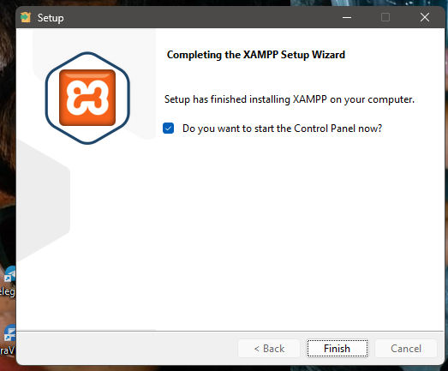

This shows the successful installation of XAMPP, which provides Apache and MySQL services required for local web development.
Apache and MySQL Running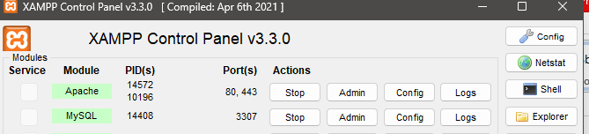

This shows Apache and MySQL services running in the XAMPP control panel, confirming that the local server environment is active.

Localhost test page
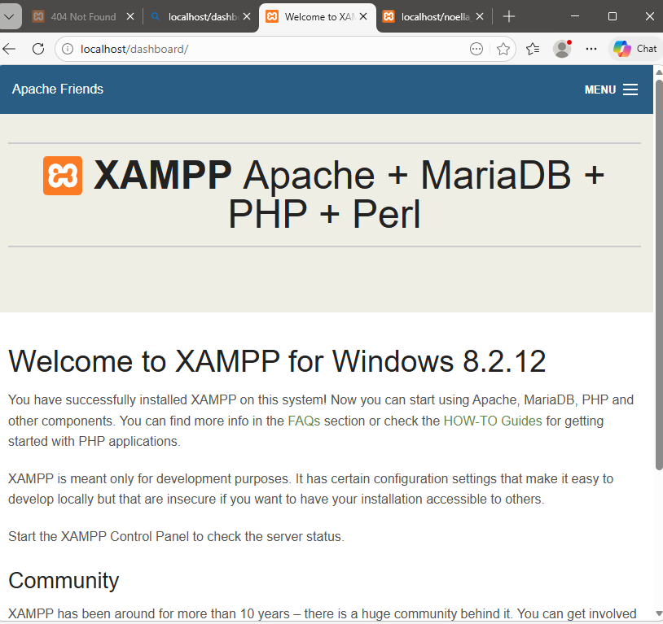

This demonstrates that the localhost server is working correctly by displaying the default XAMPP page in the browser.

Hello World Test

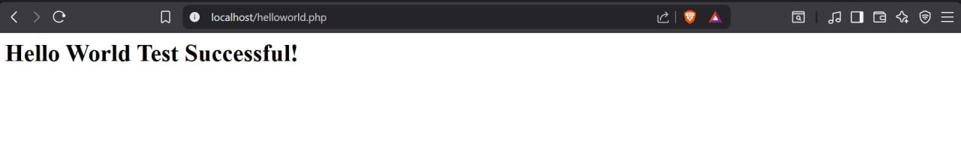
This shows a simple PHP/HTML “Hello World” page used to test that the server can execute and display web pages correctly.

Database connection test

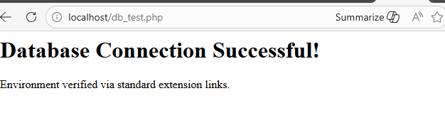
This figure shows successful connection between PHP and MySQL using mysqli_connect(). This confirmed that Apache and MySQL services were properly configured in XAMPP.

Technologies selected
PHP+MySQL

Week 2: WireFrames and GUI Design
Title

User Interface Planning and System Design

Fig1 Hand drawn Wireframe
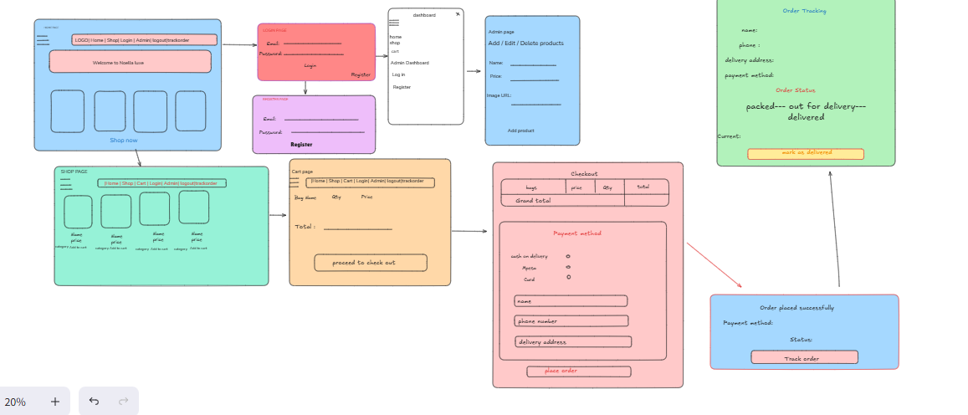

This shows the initial wireframe of the system, which was used to plan the layout and structure of the user interface before development.

Dashboard Layout Design
This demonstrates the dashboard layout, showing how different sections are arranged to improve usability and accessibility.

MobileView Mockup

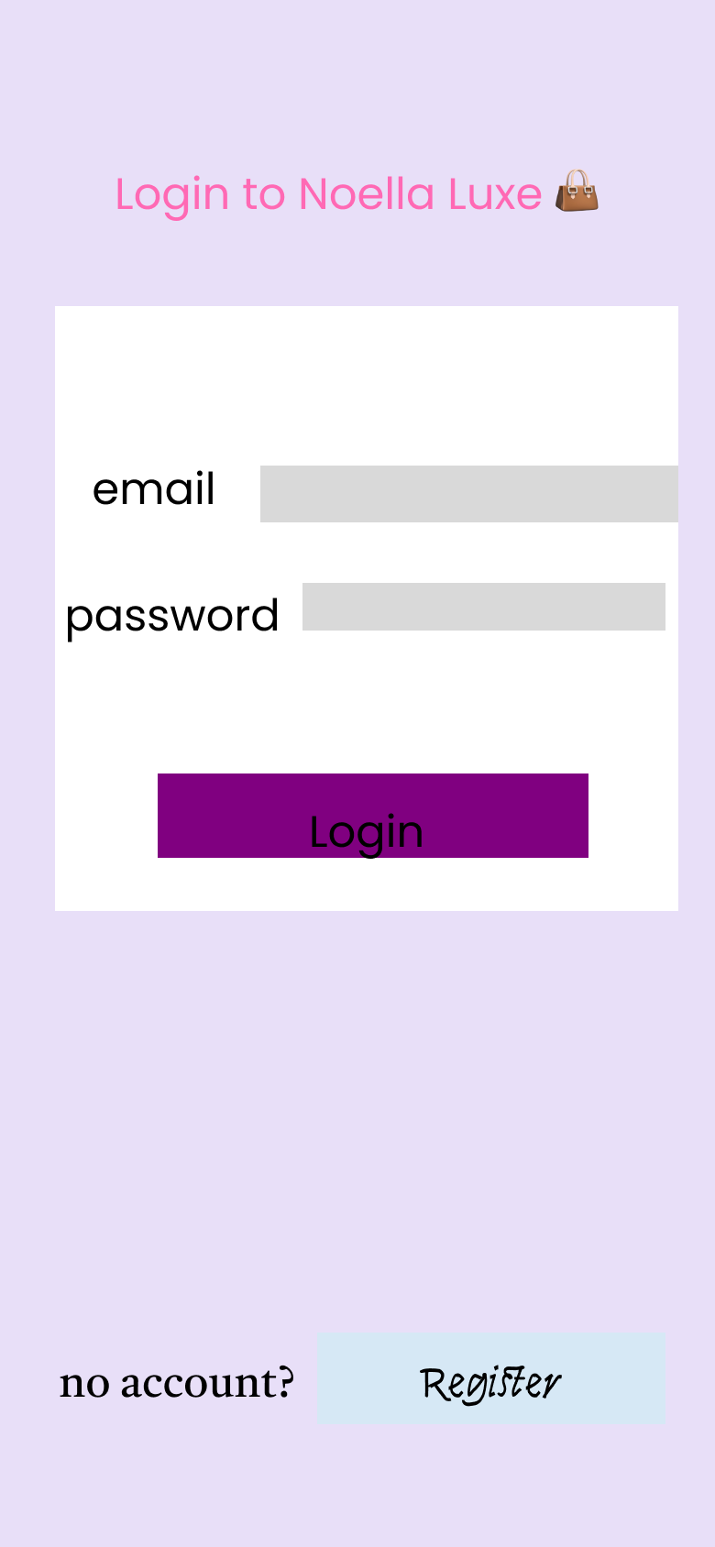

WEEK 3 : JavaScript and PHP basics

Frontend and back end foundations

JavaScript form validation
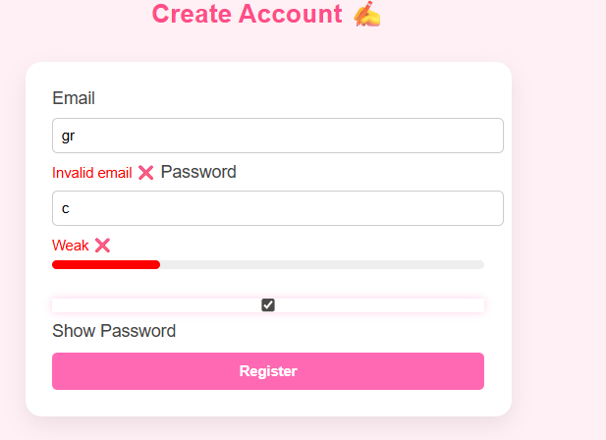
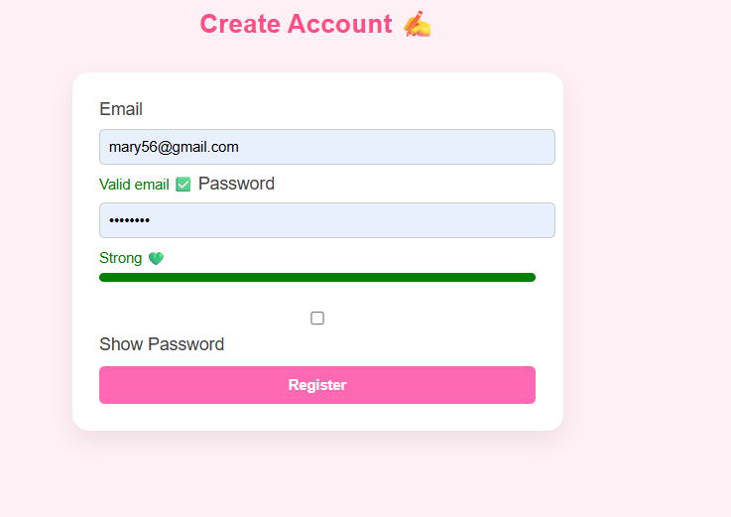
This demonstrates JavaScript form validation used to prevent users from submitting empty or incorrect input fields before data is sent to the server.

Password strength checker


This shows how JavaScript is used to check password strength, ensuring users create secure passwords and improving system security

PHP Syntax Practice
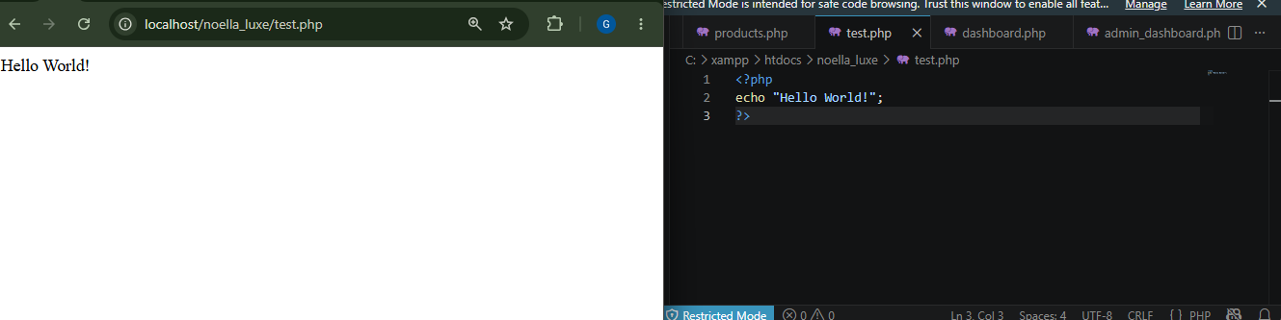
This demonstrates basic PHP syntax used for server-side scripting and processing user requests.

Database connection script

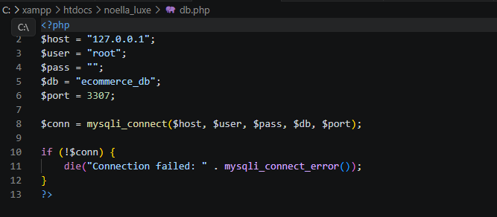
This shows successful connection between PHP and MySQL using mysqli_connect(), enabling communication between the application and the database.

Dynamic user input handling
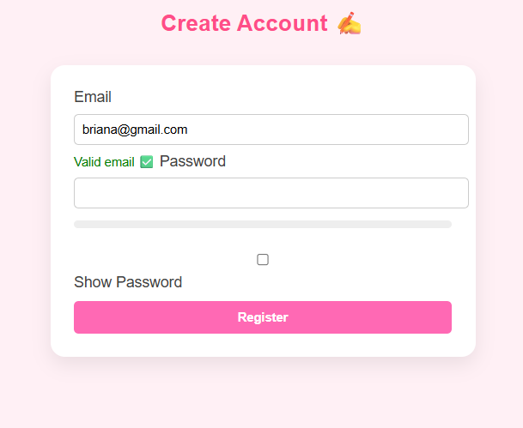
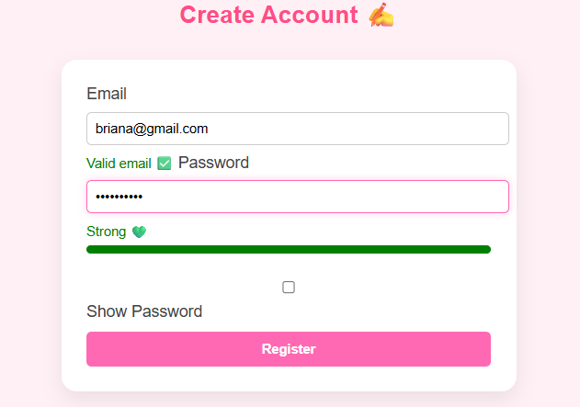
This demonstrates how user input is captured from forms and processed dynamically using PHP for validation and storage.

4. Technologies used
HTML - structure
CSS - design
JavaScript - validation

PHP - processes form data and logic
MySQL - stores user information.
XAMPP - local server to run PHP and MySQL

WEEK 4: Based on system development progress
Fig1

User registration form
This shows the user registration form where users enter their details such emails and password.
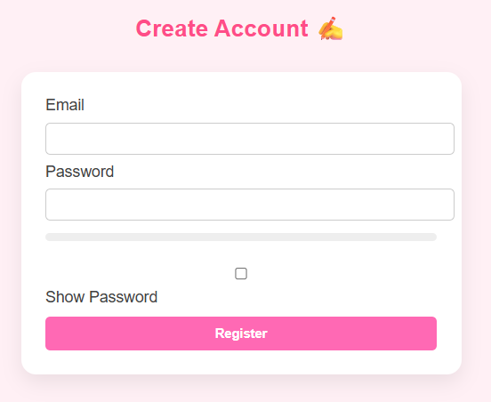

Fig 2: Data submission to database
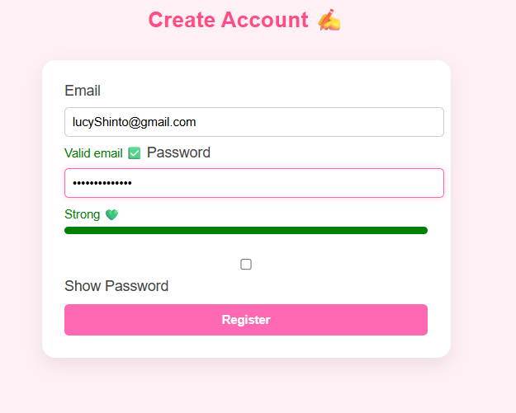

This figure demonstrates how user data is submitted from the registration form and stored in the MySQL database using PHP. The password is securely encrypted using password_hash() before being saved.

Login system
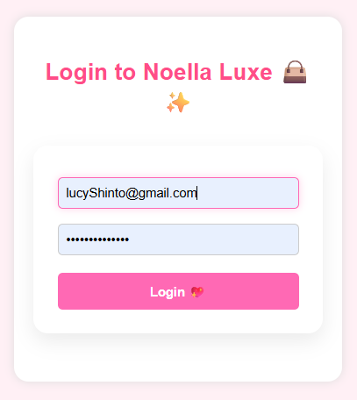

This figure shows the login functionality where users enter their email and password. The system retrieves the user record based on the email and prepares it for authentication.

Successfully login/Dashboard Access

This figure demonstrates successful user authentication. After verifying the password using password_verify(), the user is granted access and redirected to the dashboard, with a session created to maintain login state.


Error handling (invalid login/validation)
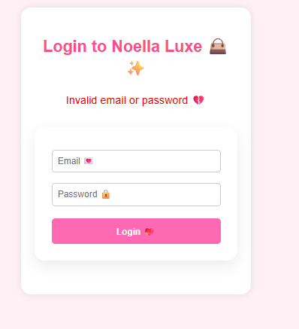
This figure shows how the system handles errors such as incorrect login details or empty input fields. Appropriate validation messages are displayed to guide the user and improve system usability.

TOOLS AND TECHOLOGIES USED
PHP
MySQL
XAMPP
HTML
phpMyAdmin

WEEK 5: Database components and CRUD operations

Step 1: Create your Database (phpMyAdmin)
In this stage a structured database was created to support the applications.
Multiple tables include Users, Products, Carts were designed to store and manage
data efficiently.

Step 2: Create Users table

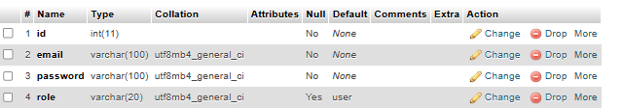
The create operation allows new data to be added into the system. In this figure
Users can register accounts

Step 3: Insert Sample Data

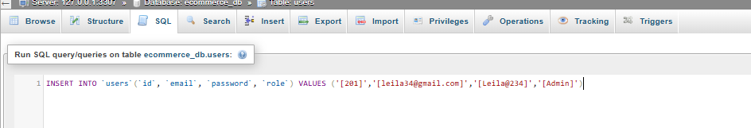

The INSERT operation is used to add new records into the database. In this figure I inserted a new user as an admin to the system. Data entered by the user is collected through a form and stored in database using SQL INSERT statements.

Step 4: Connect PHP to Database
I created a db.php file
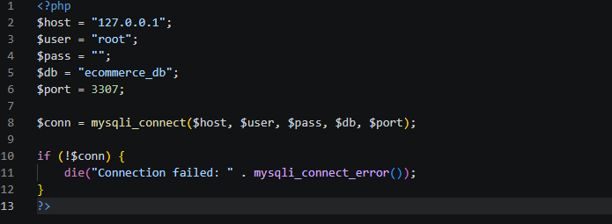
The file is created to allow communication between application and the database
This ensures that data can be stored, retrieved, manipulated dynamically.

Step5: READ (Display users)

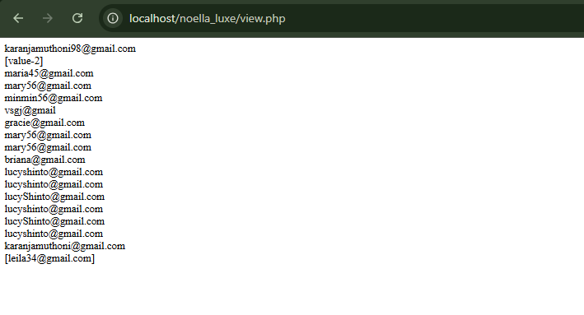
The READ operation retrieves data from the database and displays it to the user.
This enables users to view available products and items in their cart.

Step6: UPDATE Data



The UPDATE operation allows modification of existing data in the database. In this
System, Users can update the quantities of items in their cart.

Step 7: DELETE Data

The DELETE operation removes unwanted or unnecessary data from the system.
This helps maintain accurate and relevant records.

Reflection
This week I learned about databases systems and how to integrate them with web applications. I created a database and tables using MySQL and performed CRUD operations such as inserting, retrieving, updating and deleting records. I also connected PHP to the database and displayed dynamic data on the website. Additionally, I practiced SQL queries and improved my understandings of backend integration.
Week 6: Database integration and CRUD operations
Creating Database
I created a database ecommerce_db and tables like products.
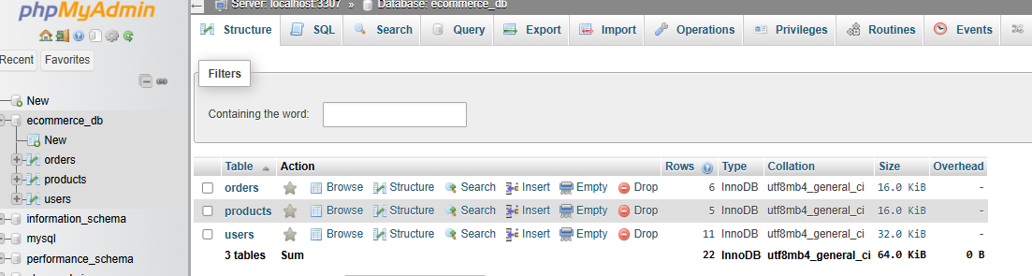

Connecting PHP to MySQL
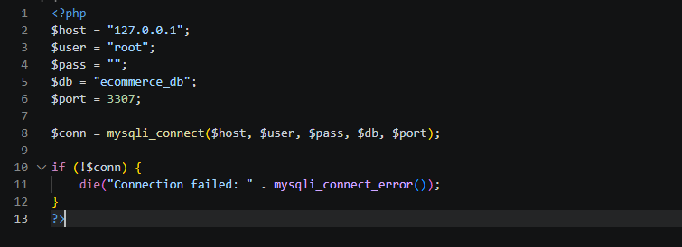
I created a separate db.php file was created to connect PHP to MySQL using the mysqli_connect function. This allows all pages to interact with the database

Creating table
I created the products table
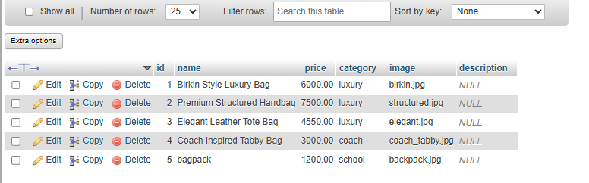

Adding new products


The admin can add new products using a form where the data is inserted using PHPMySQL queries.
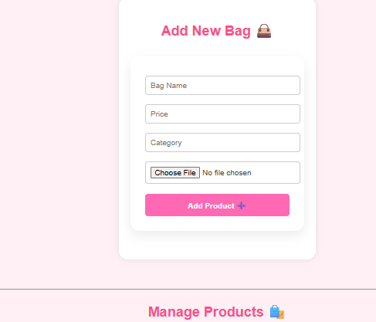

Read operation

Displaying the products to the users

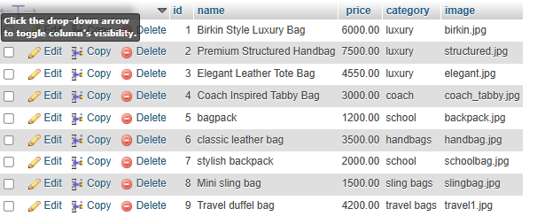

All products are retrieved from the database and displayed on the products page

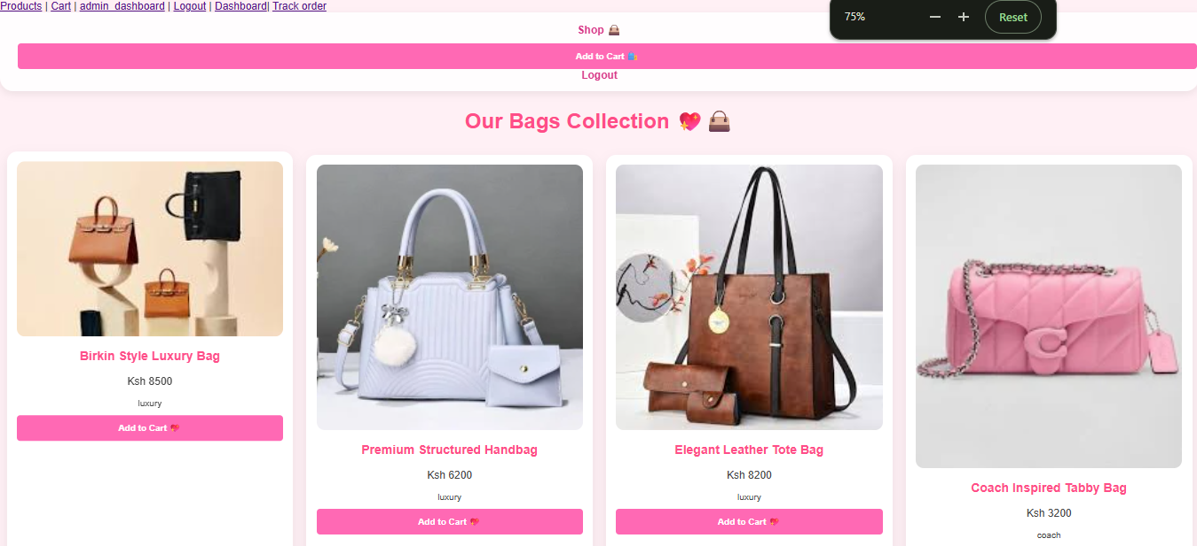

Update operation
Editing existing records.
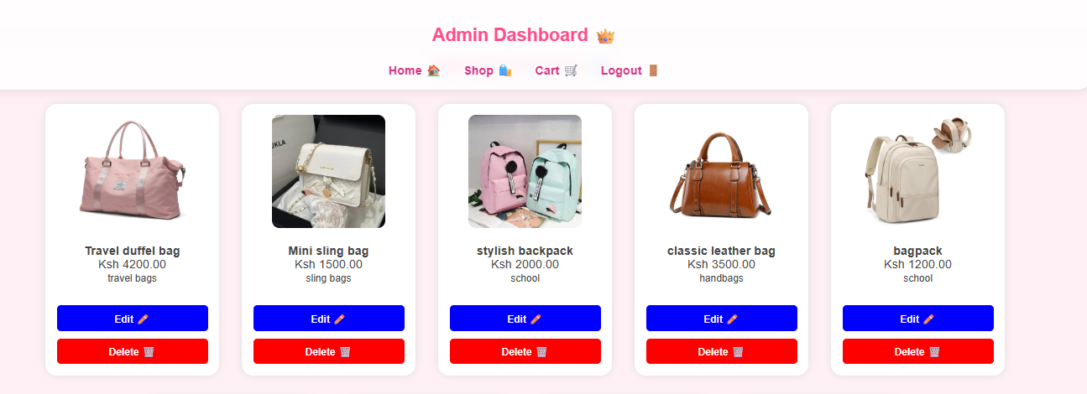

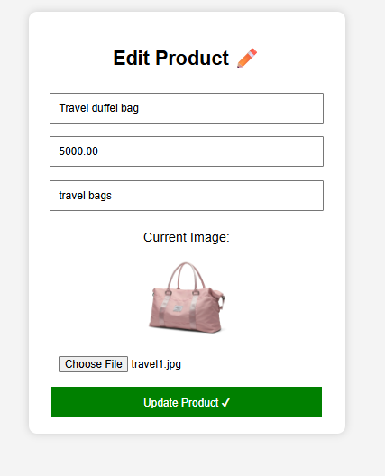

This is an edit page where admin can update records.


This figure shows updated product list
This figure shows database that shows changed values in price.
Delete operation


This figure shows the product I want to delete from my page
Reflects a message after a successful deletion
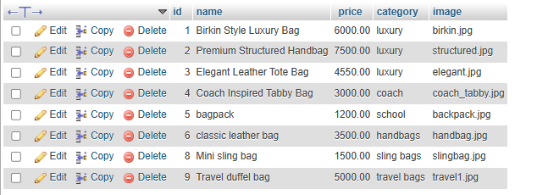
The figure shows that admin deleted the stylish backpack and the changes reflected in the database

Week 7: User Authentication and session Management
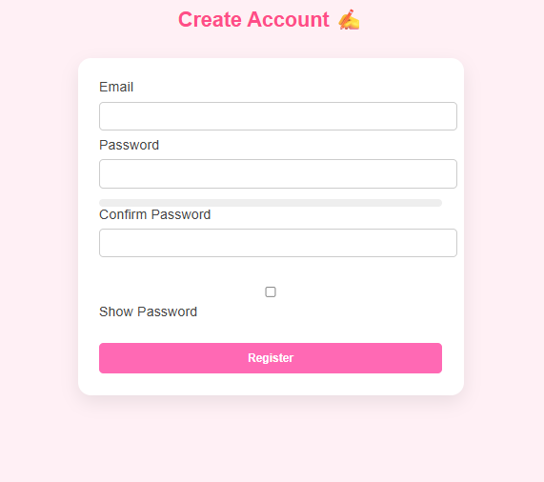
The figure shows the user registration form where new users enter their details. The password is hashed before storing in their database.
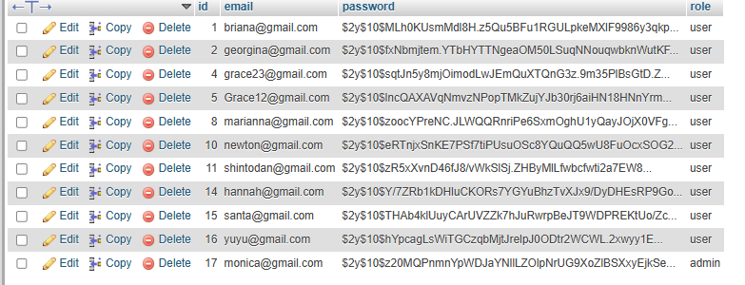
This figure shows the users table where the registered users data is stored and the password is encrypted using hashing.
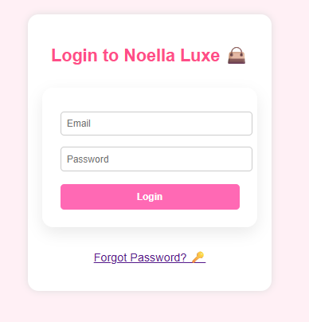
The figure shows the login page where users enter their details to access the system.

The figure show the home page after the user has logged in
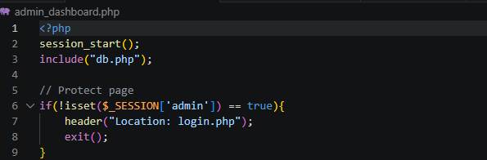
The figure shows the admin_dashboard.php that show only the admin can access it.
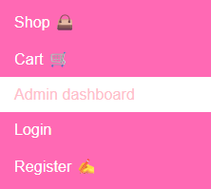
This figure captures a user trying to open the admin dashboard page.
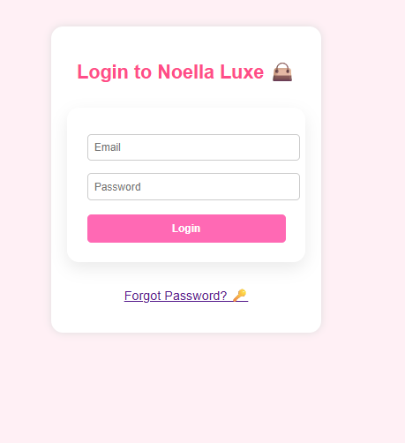

The user is redirected to login page and is denied access to the page. This demonstrates page protection.

This figure shows the logout functionality. The session is destroyed and the user redirected to the login page.
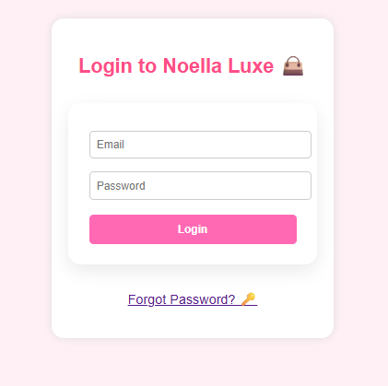

WEEK 8: RESPONSIVE WEB DESIGN &MOBILE-FIRST DEVELOPMENT

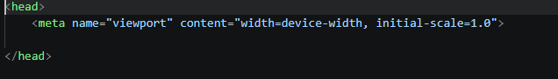
The figure shows the viewport meta tag used to ensure proper scaling and responsiveness on different devices.
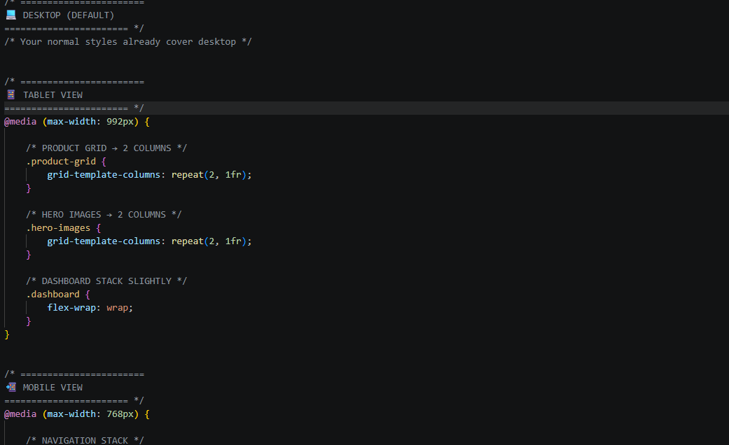
The figure shows media queries were used to modify the layout for mobile devices.

3.tablet view
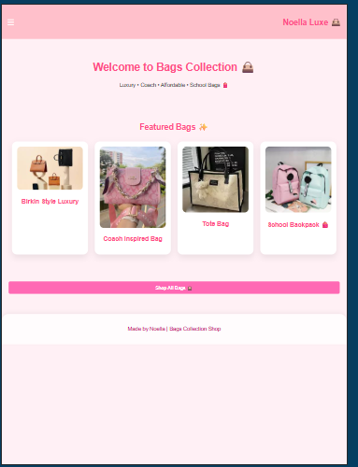
This figure shows how the website layout adjusts for tablet-sized screens.
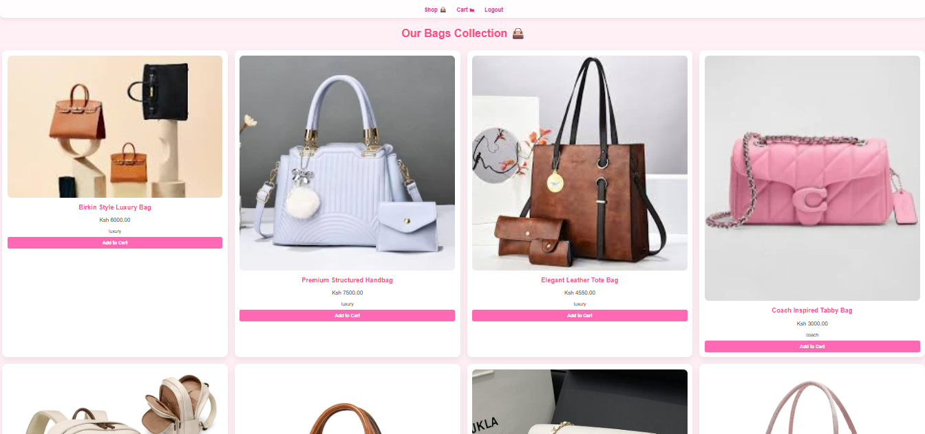
The figure displays the full desktop version of websites. It is a default layout that was designed for larger screens with full width sections.
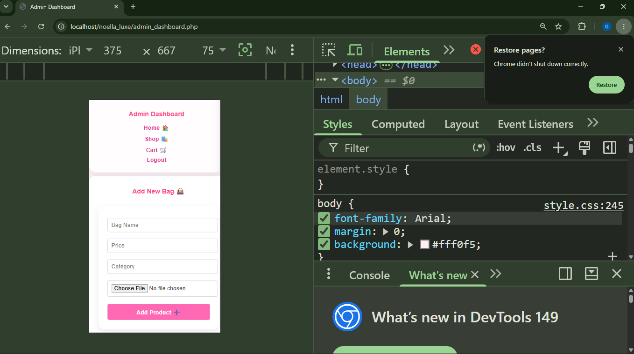

The figure shows the website being tested for responsiveness using chromeDevTools. Different screen sizes such as mobile,tablet and desktop are simulated

